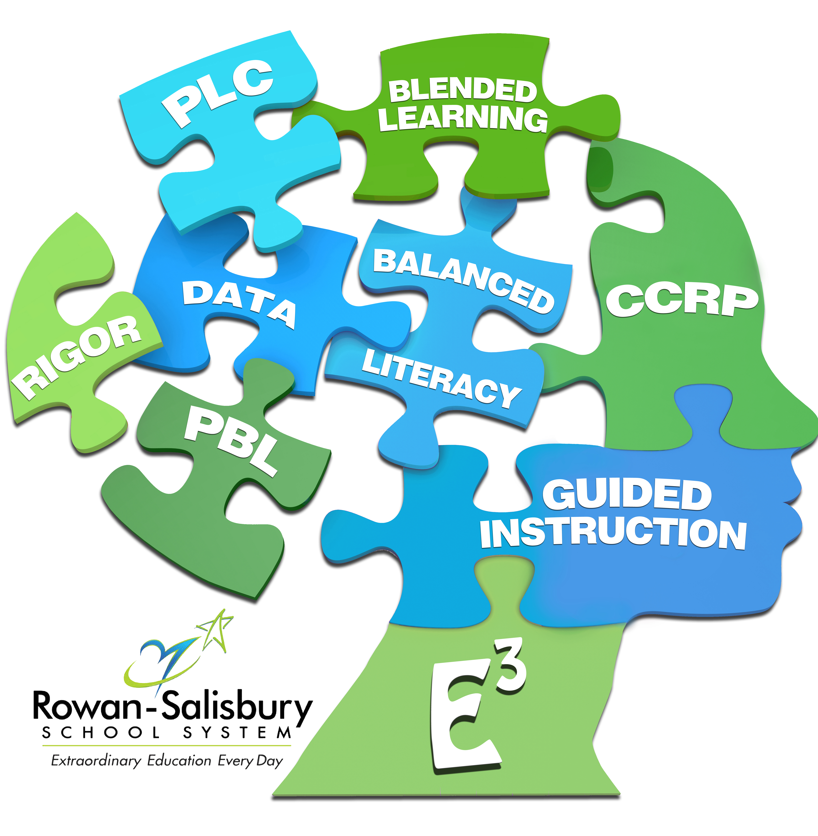

Honors Math 2 Syllabus

This course follows the conceptual categories set by the North Carolina Department
of Public Instruction. Students will learn and explore, and be introduced to rigorous concepts dealing with geometric and function transformations, quadratic functions, square root and inverse variation functions, similarity and congruence, solving right triangles, and probability. This course is the second of four required for High School graduation. The Honors Math 2 course will expect students to engage in higher level problem solving and be responible for their learning. The delivery of this course stresses real-life applications and developing mathematical literacy and problem-solving strategies.

At the end of this course, you will be able to perform rigid geometric transformations, analyze and solve quadratic, square root, and inverse variation functions, prove similarity and congruence of triangles, solve right triangle trigonometry, and compute probabilities of compound and conditional events.

NEEDS AND RESOURCES

Required Materials

To successfully complete this course, you will need…
- 3 Ring Binder with notebook paper or a 3 Subject Spiral Notebook with Pockets
- Pencils
- Graph Paper (Optional)
- TI-84 Plus (Optional); Classroom Sets are Available
- AAA Batteries(Optional); Extra Credit up to 2 packs of 4

Online Resources
- Mrs. Morris' Weebly
- rss.schoology.com
- Discovery Education
- www.desmos.com

COURSE SCHEDULE

This course covers the given units. The times given are suggestions plus or minus days at the discretion of the teacher.
- Transformations Semester: 10 days
- Quadratic Functions Semester: 19 days
- Square Root & Inverse Variation Functions: Semester: 13 days
- Similarity and Congruence Semester: 15.5 days
- Solving Right Triangles Semester: 7 days
- Probability Semester: 8 days

POLICIES AND PROCEDURES

Classroom Expectations:
- Students are expected to be in class and ready to work when the tardy bell rings.
- Students are expected to come to class prepared (notebook, pencil, book, and homework).
- Students are expected to respect others and their property.
- Students are expected to follow the school policies and rules.

All cellphones are expected to be on silent and stored in a book bag or purse unless being used for a teacher-approved activity. Students may listen to music during independent non-testing/non-instructional times. Ask before you listen. Drinks with a closed lid are allowed. Gum is allowed as long as it does not cause a distraction or is left on or under desks/tables. Food is allowed during special circumstances.

Group Work Rules/Expectations:
Every member of each group is responsible for all work. If there is a disagreement, form a consensus, not a majority rule. Be constructive and respectful. Be open to other members' ideas and encourage their participation. Make sure no one is left out. Every member of each group is assigned a role that they are responsible for during the class period.

GRADING SCALE AND POLICIES
Grading Scale: A: 90-100 Grade Calculations for each Quarter:
B: 80-89 Tests/Projects: 50%
C: 70-79 Quizzes: 25%
D: 60-69 Classwork/Graded Homework: 20%
Daily Homework: 5%

There will be at least 1 cumulative test per unit. Each unit test will include material from previous units throughout the course. Quizzes may be retaken or corrected. Tests can be corrected to improve grade until one week prior to the end of the grading period.

Make-Up & Late Work Policy

- Students are expected to complete all make-up work in a time frame that is equivalent to 1 day more than days absent.
- All work is to be turned in on time. Any student who turns in a graded assignment early will receive 5 bonus points to the final score on the assignment.
- Any student who turns in a graded assignment late will have 10 points deducted from their score if completed within the unit it was assigned. Any work turned in after that unit will have 20 points deducted.

CONTACT INFORMATION

- Melissa Morris
- 704-857-1161 ext. 126; (Before or after school; planning time: 12:30 – 2:00)
- melissa.morris@rss.k12.nc.us
- website: http://www.mbmorris.weebly.com
- Text # for Remind: 81010 Codes for Honors Math 2: 2nd Period: @ srhsmath2 Codes for Honors Math 2: 2nd Period: @ srhs2math

